**### Upload any image inside the web app path and access it through the web**

VM connected to PowerShell

* Sudo apt update
* Sudo apt install apache2
* Sudo systemctl status apache2

Open another terminal and go to downloads to put the image in VM

|  |
| --- |
| * Cd downloads/ * Ls * Sftp (ipaddress) * Put (image name) * Bye |

* Cd /var/
* Cd www/
* Cd html/
* Cat index.html
* Cd
* Sudo cp (image name) /var/www/html
* Ls
* Cd /var
* Cd www
* Cd html
* Ls

Copy the ip address of VM and paste in google search with image name

` (ip address)/(image name)

**### JAVA installation using tar file**

Create a VM in linux and connected to powershell

wget <https://download.java.net/java/GA/jdk16.0.1/7147401fd7354114ac51ef3e1328291f/9/GPL/openjdk-16.0.1_linux-x64_bin.tar.gz>

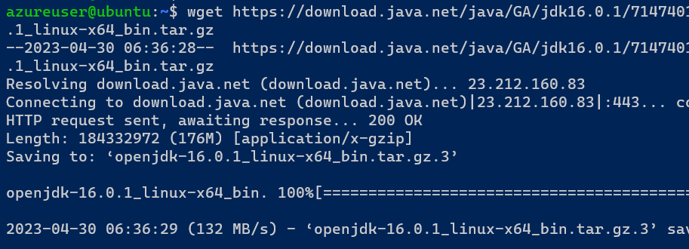

tar zxvf openjdk-16.0.1_linux-x64_bin.tar.gz

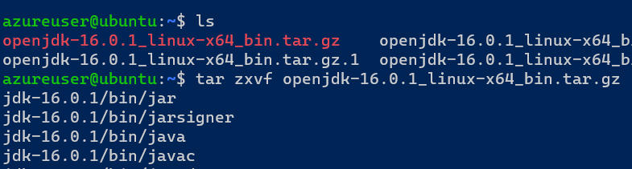

sudo vi /etc/environment

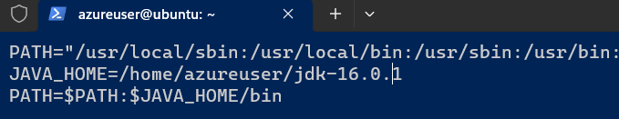

source /etc/environment

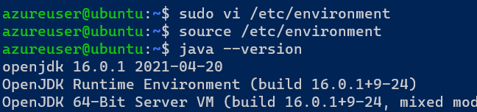

Add user

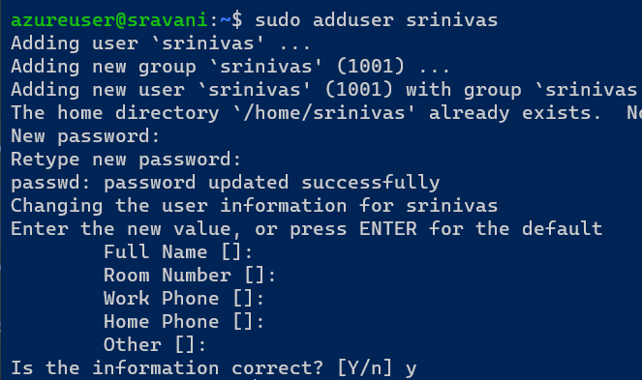

TO delete user

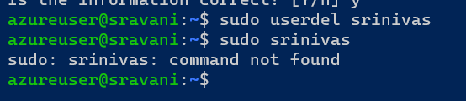

To switch user

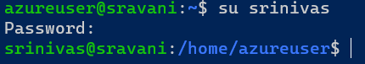

the location of users,passwords and groups

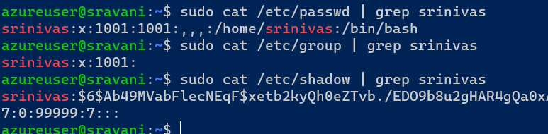

Hands-on file permissions and change owner ships

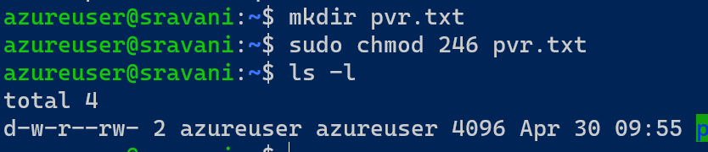

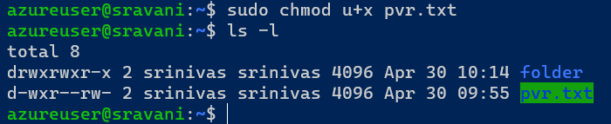

For user

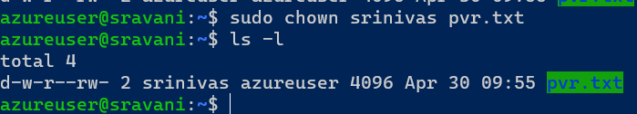

For group

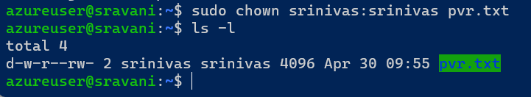

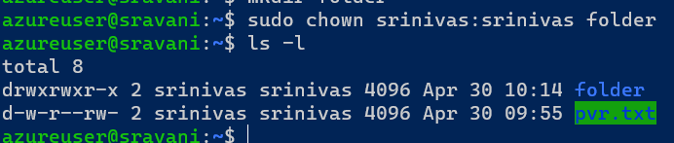

Try to create a shell file with some commands and execute/run it

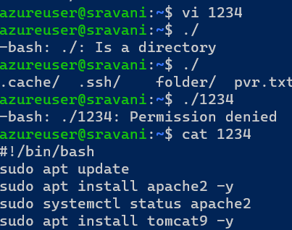

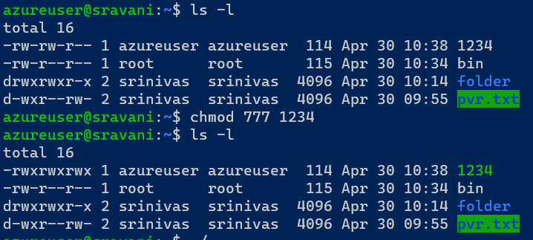

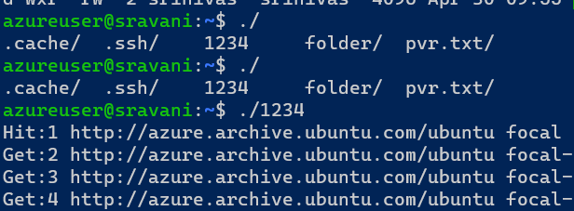

Create 50 files using a single command

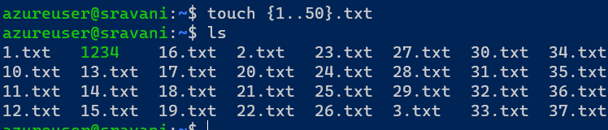

Try to install Mysql on ubuntu

